Brainstorm & Idea Prioritization
Ideation Phase
Date | 31 January 2025
Team ID | SWTID-2026-1074
Project Name | SB Stocks
Team Size | 5
Team Leader | Venkatesh Illa
Team Members | Durga Meghana Kondempudi, Chandrika Narla, Mogali Shyam, Sravani Jagu
Maximum Marks | 4 Marks

SB Stocks — Brainstormed Feature Ideas & Prioritization
# | Idea | Priority
1 | JWT-based secure registration/login | Must Have
2 | Live-updating simulated stock prices (background price engine) | Must Have
3 | Buy/Sell order execution with wallet balance validation | Must Have
4 | Portfolio holdings with average buy price calculation | Must Have
5 | Wallet Deposit/Withdraw simulator with transaction logging | Must Have
6 | Historical intraday chart per stock symbol (Chart.js) | Should Have
7 | Admin panel for user, order and transaction monitoring | Should Have
8 | Role-based authorization (adminProtect middleware) | Should Have
9 | Candlestick charts & real market data integration | Could Have (Future Enhancement)
10 | Email notifications for order confirmations | Could Have (Future Enhancement)
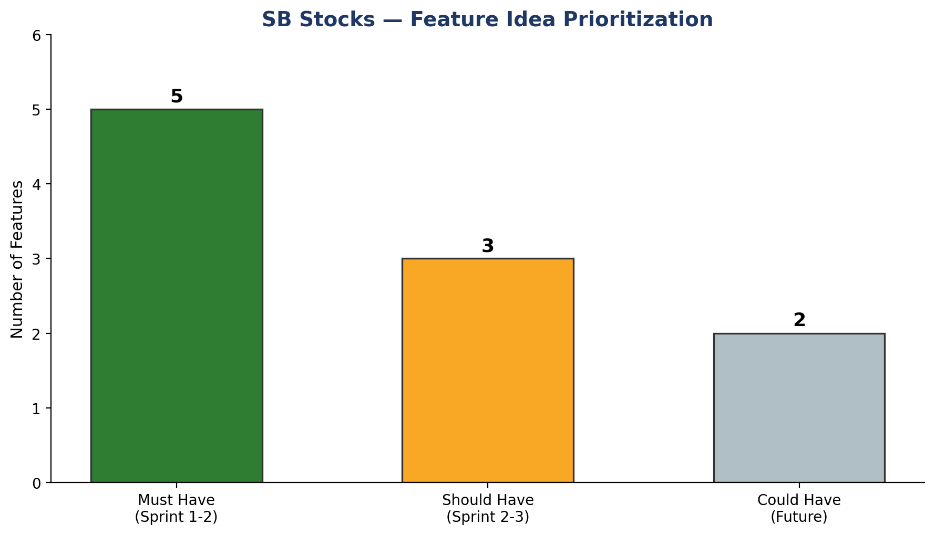
Figure: Feature ideas grouped by MoSCoW priority

Outcome
After grouping similar ideas and voting as a team, core trading and wallet functionality (Must Have) was prioritized for Sprint-1 and Sprint-2, chart visualization and the admin dashboard for Sprint-2/Sprint-3, and real-market API integration plus notifications were parked as future enhancements beyond the current scope.

